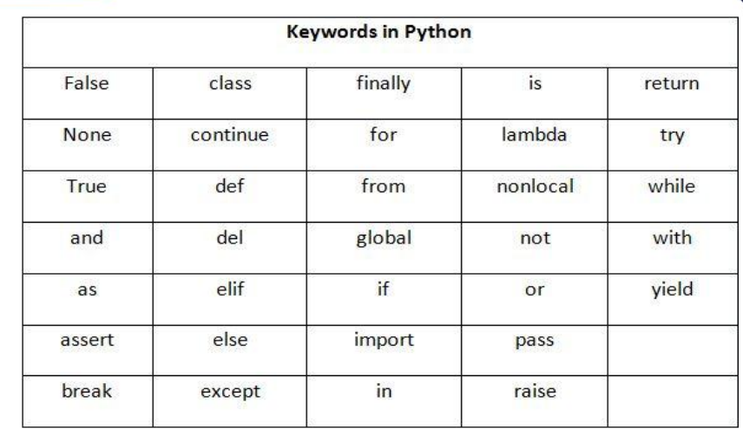

**Indentation:**

Indentation is describe the block of code

Generally 4 whitespaces are used for indentation

**Examble:**

For i in range(10,20):

print(i)

if( i ==10):

break

**comments:**

**single line comment :** # this is demo

**multiple line comment : “””………”””**

**DATA TYPES IN PYTHON**

**1. Numbers**

**2. String**

**3. List**

**4. Tuple**

**5. Set**

**6. Dictionary**

**1.Numbers:**

**Three types:**

**1.int**

a=10

type(a)

**2.float**

**a=35.6**

**type(a)**

**3.complex**

**a=15+5j**

**type(a)**

**String:** String is a sequence of Unicode character. The user can use **single quotes or double quotes** .String are **immutable** object in python

s=’hii I am karan’

print(s)

type(s)

**List :**

The list is stored as an ordered sequence of items, this items are **mutable.** Itemsseparated by commas are enclosed within **square bracket[]**

a = [10,20,30,40,50]

print(a)

type(a)

**Tuple:**The list is stored as an ordered sequence of items, this items are **immutable.** Itemsseparated by commas are enclosed within **parentheses bracket()**

t=(10,20,30,’hii’)

print(t)

type(t)

**set:**The set is an **unordered collection** of unique elements**. immutable** behaviour. Values separated by commas inside **curly braces{}**

a={10,20,30,”karan”,10}

print(a) #{10,20,30,”karan”}

print(type(a))

**Dictionary:**

The Dict is an **unordered collection** of **key value pairs** this written with two curly braces {}

d={“name”:”karan”,”age”:22,”address”:”Chennai”}

print(type(d))

print(d)

print(d[“name”])

**variables:** variables using for storing the data

name=”karan”

x=1

**Rules of create variables:**

* A variable name must start with a letter or the underscore character.
* A variable name cannot start with a number.
* A variable name can only contain alpha-numeric characters and underscores (A-z, 0-9, and _ )
* Variable names are case-sensitive (age, Age and AGE are three different variables)

Python Operators

Operators are used to perform operations on variables and values.

In the example below, we use the + operator to add together two values:

Example

print(10 + 5)

**list of operators:**

* Arithmetic operators
* Assignment operators
* Comparison operators
* Logical operators
* Identity operators
* Membership operators
* Bitwise operators

1. **Arithmetic operators:**

|  |  |  |
| --- | --- | --- |
| **operators** | **Name** | **Example** |
| **+** | Addition | **x + y** |
| **-** | Subtraction | **x - y** |
| **\*** | multiplication | **x * y** |
| **/** | Division | **x / y** |
| **%** | modules | **x % y** |
| **\*\*** | Exponentiation | **x ** y** |
| **//** | Floor division | **x // y** |

## Assignment Operators

Assignment operators are used to assign values to variables

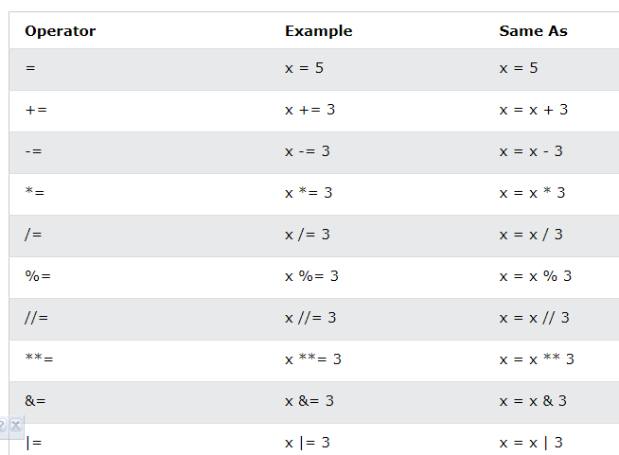

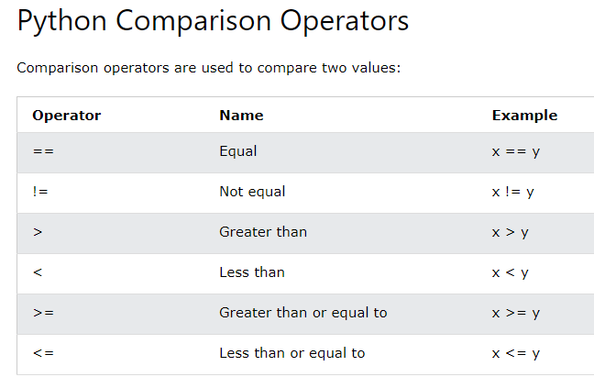

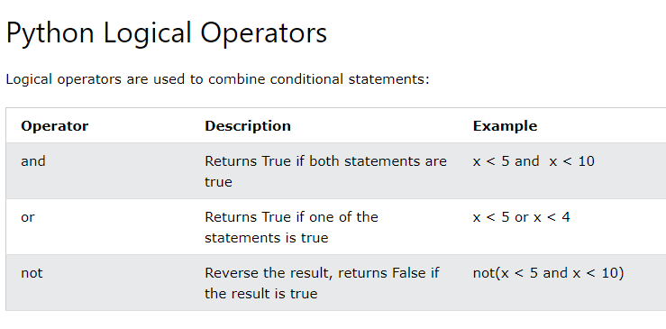

**Identity operator:**



